–

Dharmsinh Desai University, Nadiad

Faculty of Technology, Department of Computer Engineering

B.Tech. CE Semester – V

Subject: (CE-515) Advanced Technologies

Project Title:

Discussion Forum

By:

Savaliya Vivek (Roll no: CE119 Id: 17CEUOG100)

Mayur Raycha (Roll no: CE115 Id: 17CEUOS115)

Guided By:

Prof. Pinkal Chavda

Prof. Niyati Buch



Dharmsinh Desai University, Nadiad

Faculty of Technology, Department of Computer Engineering

**CERTIFICATE**

This is to certify that Advanced Technologies project entitled “Discussion Forum” is the bonafied report of work carried out by

1. **Savaliya Vivek (17CEUOG100)**

**2) Mayur Raycha (17CEUOS115)**

Of Department of Computer Engineering, Semester V, academic year 2019-20, under our supervision and guidance.

|  |  |  |
| --- | --- | --- |
| Guide | Guide | HOD |
|  |  |  |
| **Prof. Pinkal Chavda** | **Prof. Niyati Buch** | **Dr. C. K. Bhensdadia** |
| Assistant Professor of | Assistant Professor of | Head of the Department of |
| Department of Computer | Department of Computer | Department of Computer |
| Engineering, Dharmsinh Desai University, Nadiad. | Engineering, Dharmsinh Desai University, Nadiad. | Engineering, Dharmsinh Desai University, Nadiad. |

1. INDEX

1. Introduction……………………………………………………………………….….................4 2. Technology and Tools Used .......................................................................................................4 3.Software Requirement Specifications ………………………...……………………………...…5 3.1 Scope ………………………………………………………...………………………………..6 3.2 System Functional Requirements ……………….…………………………………………....7 3.3 Other Non‐Functional Requirements ……………….…………………………………….....11 4.Design……………….……….……………………….……………………………..…………125.E-R Diagram ………….………………………………………………..………………..…….15 6. Data Dictionary………..………………………………………………………………...….....16 7.Implementation Details ……………………………….……………………………….…...….17 8. Screen‐shots of the System …………………………………………………......……..……...19 9 Limitations and Future Extensions of System ……………………………………………...…24 10 Bibliography ……………………………………………………….……………………..….25

1. Introduction

Discussion Forum is question and answer site for professional and

Enthusiast user. Discussion forum is allowed to user share their knowledge, idea,

New thoughts and research with others in form of blogs, comments or answers.

This system provide functionality to user ask question, doubt and error to other,

Other User give solution or answer in form of comments.

Discussion forum is written in angular framework, and mongodb

Database and NodeJs server. Unregistered user has access to most of site’s

Functionality, while users who sign in can gain access to more functionality,

Such as asking or answering a question, establishing profile.

2. Tools/Technologies

**Technologies:**

HTML 5

CSS 3

Bootstrap 4

Angular cli

Typescript

Javascript

Node JS

Express JS

MongoDb

RichText Editor API

REST API

JWT API

**Tools:**

* Sublime Text
* Visual studio code
* MongoDb Compass

**Server Platforms:**

localhost/4200 for Angular

localhost/8080 for Node js

localhost/3000 for express js

mongodb://127.0.0.1:27017

Platforms:

* Google Chrome
* Mozilla firefox

3. Software Requirement Specifications

**3.1 Product Scope**

This system is designed to enable user to ask question, answer question,

Post blogs and comments on blog. It’s also provide delete or update functionality to

respective user.

**3.2 Types of User**

1. Admin

2. Author

3. Users

**3.3 System Functional Requirements**

**R.1 Admin**

R.1.1 Manage System

Description: Admin will delete or update User , Blog and Comment

R.1.1.1 Delete User

Description: Admin Delete any User of System.

Input: Admin Click Delete Button

Output: Success message

R.1.1.2 Manage Blog

Description: Admin manage all user blog, they can update it or delete it.

R.1.1.2.1 Update Blog

Input: blog data

Output: successful updation

R.1.1.2.2 Delete Blogs

Input : User selection

Output: Success message

R.1.2 Manage Comment

Description: Admin can delete any comments

Input: user selection

Output: success message

R.1.3 View feedback

Description: Admin can view the feedback

Input : User selection.

Output: list of feedbacks

**R.2 Author**

Description: Author can delete or update own blogs or comments only.

R.2.2 Delete blog

Description : blog author can delete own blog.

Input: User selection.

Output: success message

R.2.3 update comment

Description: comment writer can update comment.

Input: new comment details.

Output: Success message.

R.2.4. delete comment

Description:Comment writer can delete own comment.

Input: user selection

Output: success message.

R.2.5 Add Feedback

Description: User can give feedback of agency.

Input: Feedback.

Output: Success message.

**R.3 Users**

**Description:** User can view all blogs list, add comments, view comments, view user list, view user profiles.

R.3.1 view all blogs

Description: User can view all blogs list.

Input: Command.

Output: Response.

R.3.2 add comments

Description: User can add comment on any blogs.

Input: Comment Details.

Output: View comment list.

R.3.3. view comments

Description: User can view all comments given by other users.

Input: Command.

Output: View lists.

R.3.4. View user list

Description: User can view all user list.

Input: View command.

Output: View user lists.

R.3.5 View user profiles

Description: user can view all other user profiles.

Input: Command.

Output: view user details.

R.4 Authentication functionality

R.4.1 Signup as New User

Description: register in system

Input: user data

Output: registration successful

R.4.2 Login in system

Description: login in system

Input: user id and password

Output: login in system

R.4.3 Logout

Description: logout from system

Input: user selection

Output: success message

**3.4 Other Nonfunctional Requirements**

**1. Performance**

The system must be i­­nteractive and the delays involved must be less. So in every action-response of the system, there are no immediate delays. In case of opening App components, of popping error messages and saving the settings or sessions there is delay much below 3 seconds.

**2. Safety**

User details should be securely stored to the server. The main security concern is for user account hence proper login mechanism should be used to avoid hacking.

**3. Reliability**

As the system provides the right tools for discussion, problem solving it must be made sure that the system is reliable in its operations and for securing the sensitive details.

**4. Database**

System requires to access users data fast to maintain the performance.

4. DFDs

–––––––––––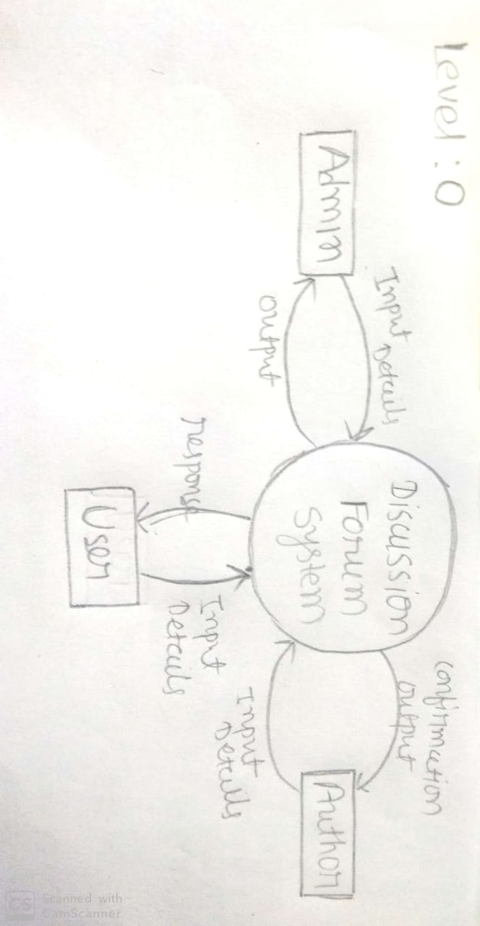

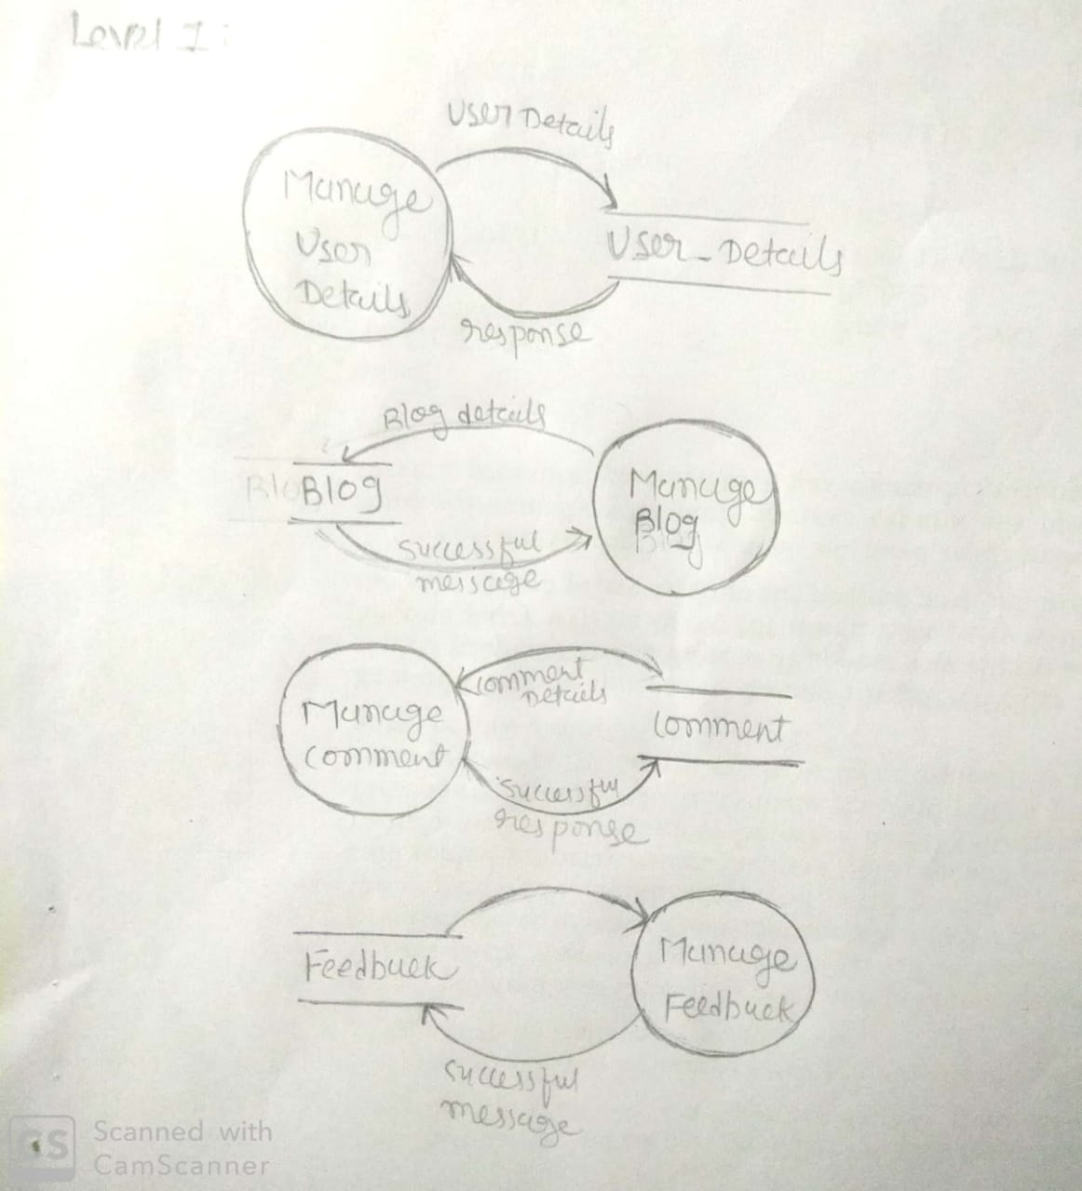

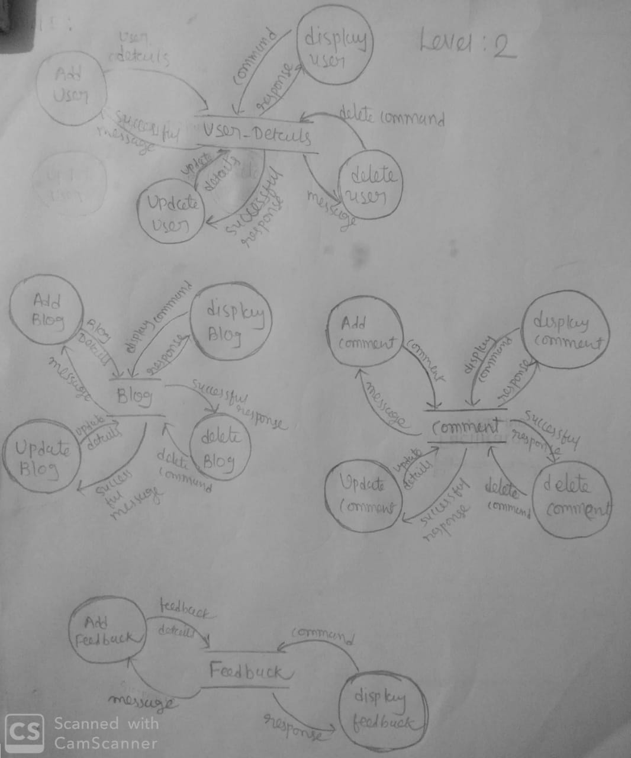

5. E-R Diagram

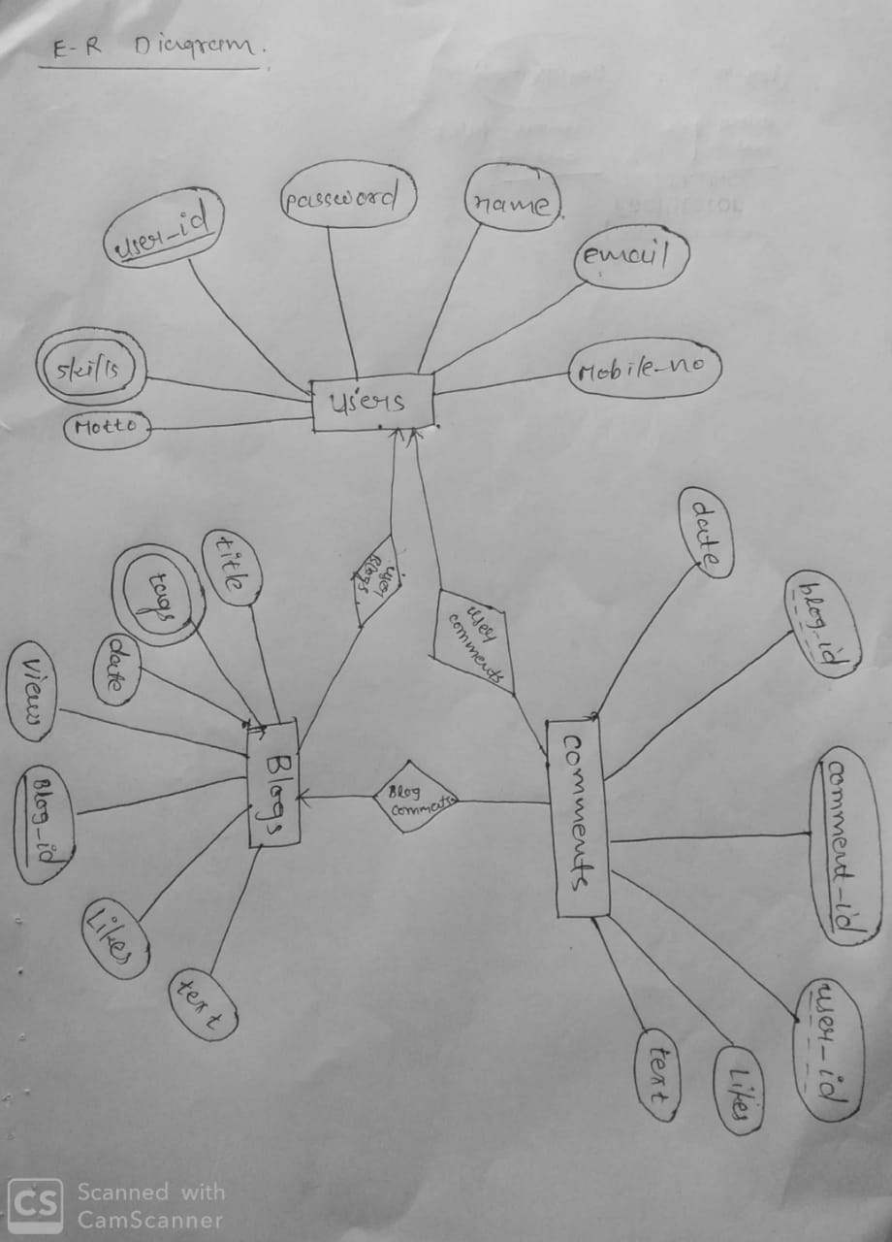

6. Data Dictionary

**1.Users**

|  |  |  |  |  |  |  |
| --- | --- | --- | --- | --- | --- | --- |
| No. | Schema | Type | Length | Required | NULL | PK/FK |
| 1 | user_id | Varchar | 15 | Yes | No | PK |
| 2 | Password | Varchar | 8-15 | Yes | No |  |
| 3 | Name | Varchar | 50 | Yes | No |  |
| 4 | Email | Varchar | 50 | Yes | No |  |
| 5 | mobile_no | Varchar | 10 | No | Yes |  |
| 6 | Skills | Varchar | 100 | No | Yes |  |
| 7 | motto | Varchar | 100 | No | Yes |  |

**2.Blogs**

|  |  |  |  |  |  |  |
| --- | --- | --- | --- | --- | --- | --- |
| No. | Schema | Type | Length | Required | NULL | PK/FK |
| 1 | Blog_id | Varchar | 15 | Yes | No | PK |
| 2 | user_id | Varchar | 15 | Yes | No | FK |
| 3 | Title | Varchar | 1000 | No | No |  |
| 4 | likes | Number |  | Default=0 | Yes |  |
| 5 | Views | Number |  | Default=0 | Yes |  |
| 6 | Tags | Varchar | 100 | No | Yes |  |
| 7 | Text | Varchar | 10000 | No | Yes |  |
| 8 | Date | Date |  | Default | Yes |  |

**3. Comments**

|  |  |  |  |  |  |  |
| --- | --- | --- | --- | --- | --- | --- |
| No. | Schema | Type | Length | Required | NULL | PK/FK |
| 1 | comment_id | Varchar | 8-15 | Yes | No | PK |
| 2 | Blog_id | Varchar | 8-15 | Yes | No | FK |
| 3 | User_id | Varchar | 8-15 | Yes | No | FK |
| 4 | Likes | Number |  | Default=0 | No |  |
| 5 | Text | Varchar | 1000 | No | Yes |  |
| 6 | date | Date |  | default | Yes |  |

7. Implementation Details

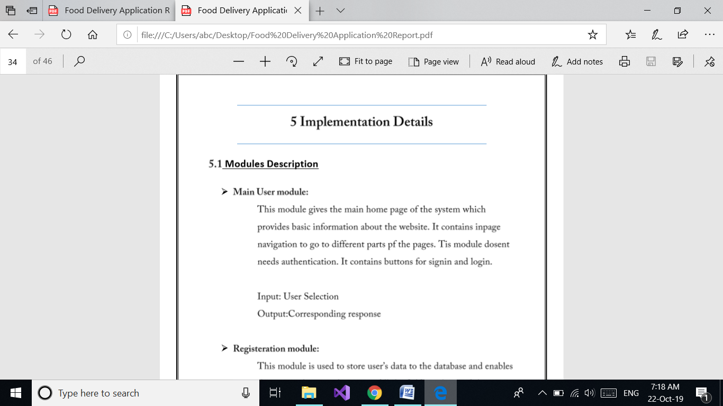

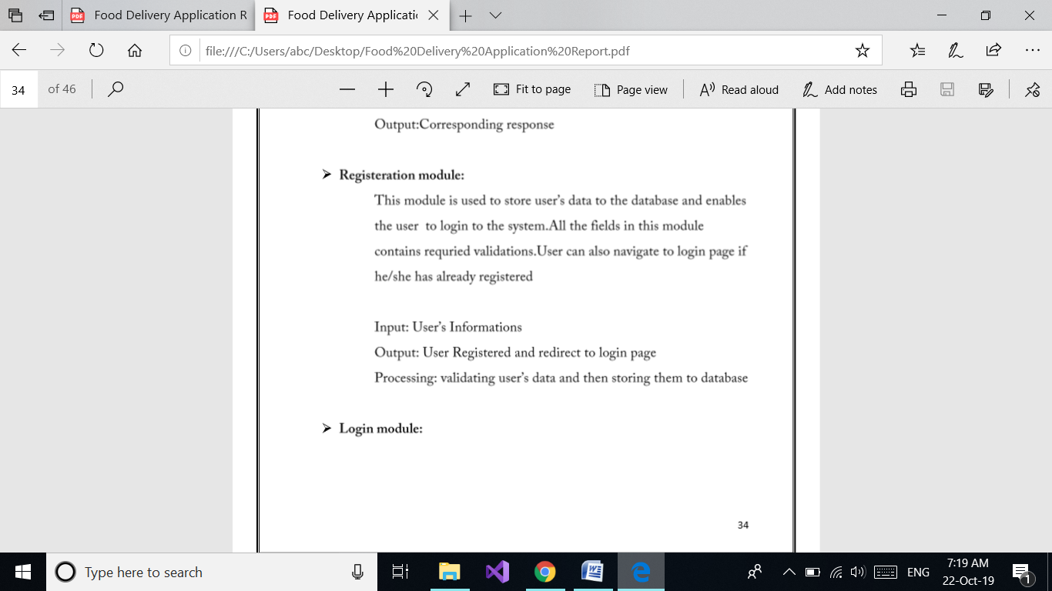

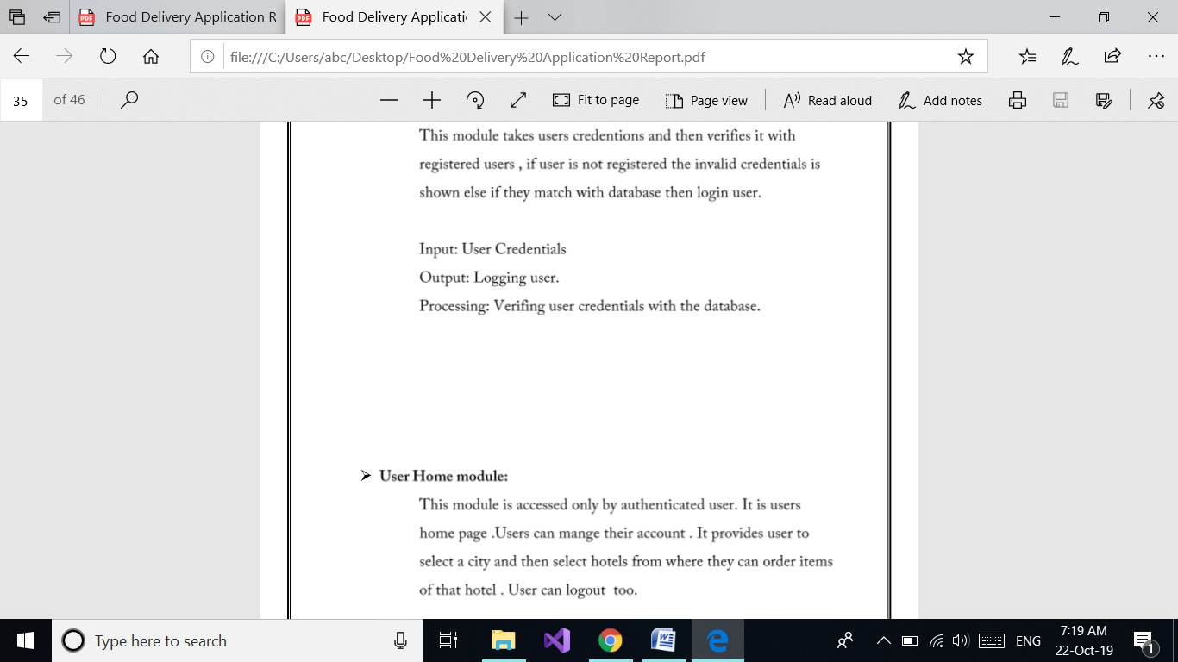



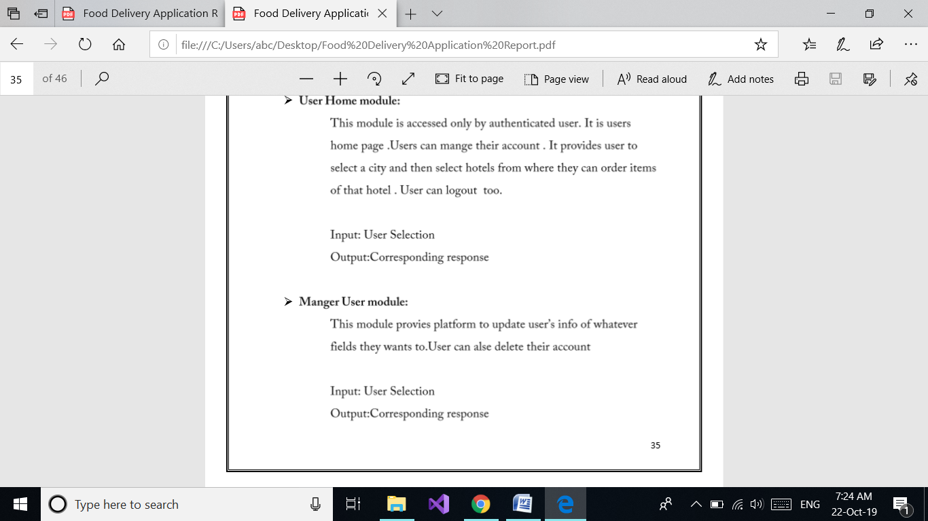

8. screen shots

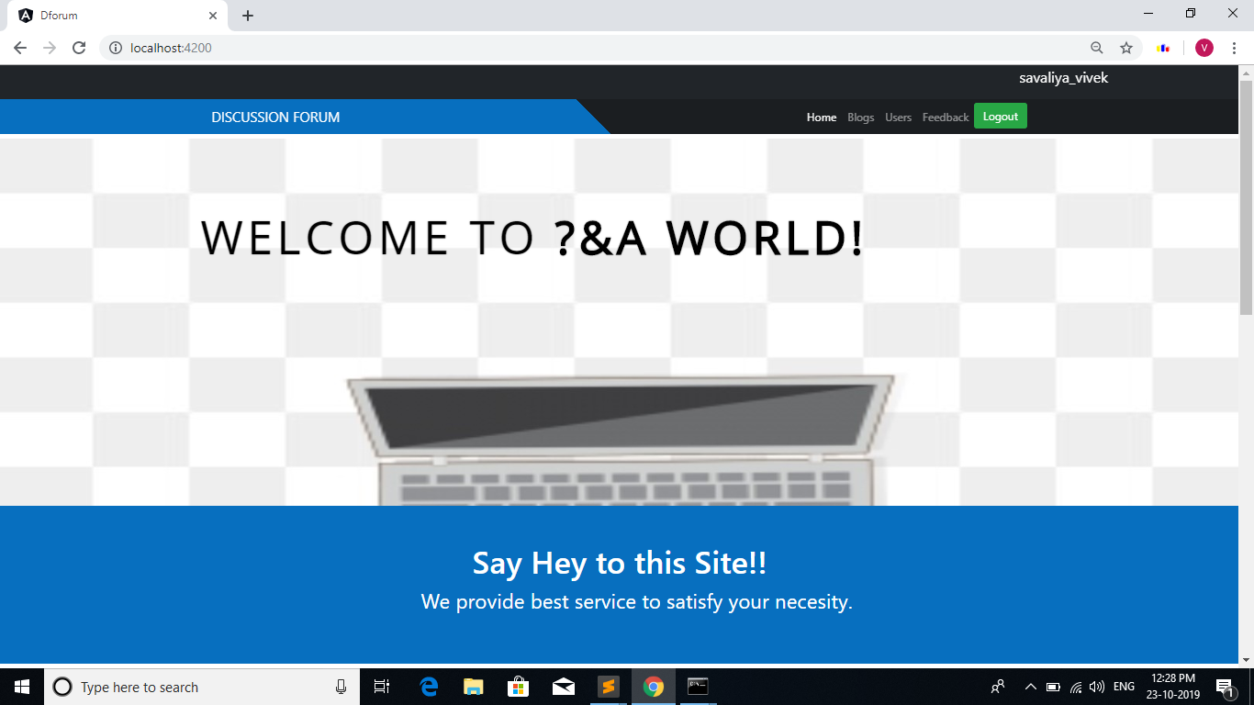

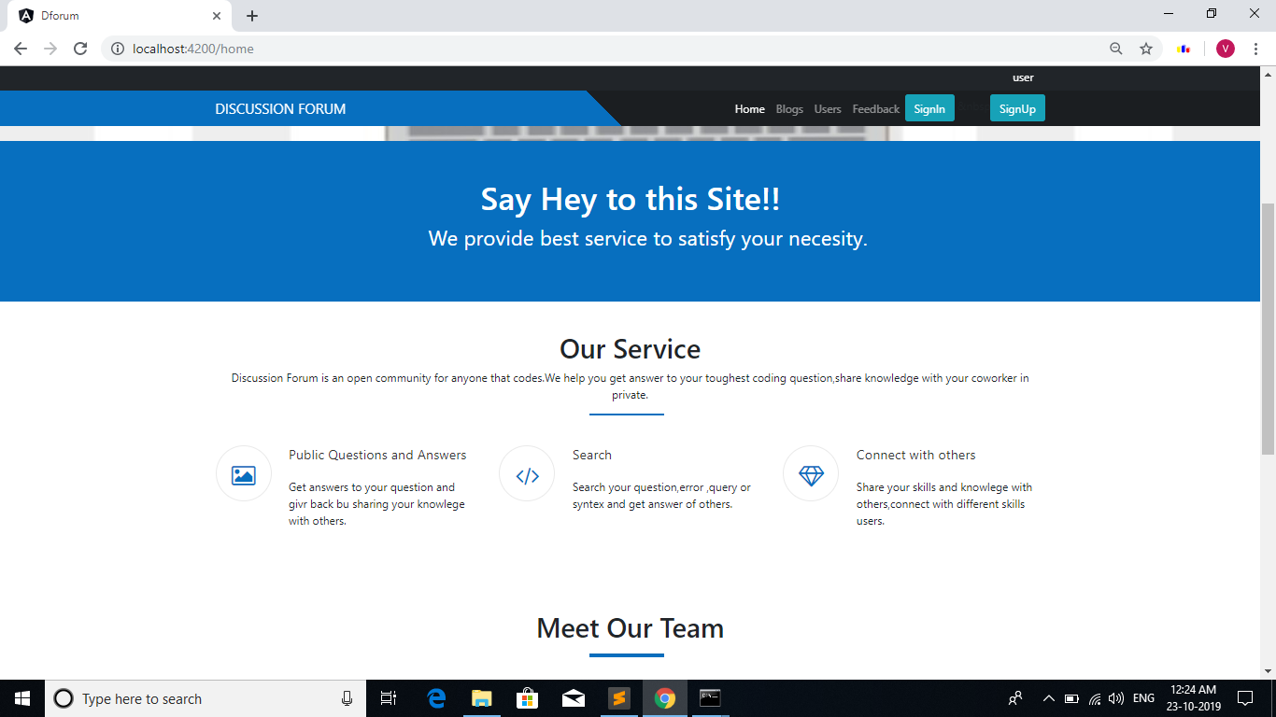

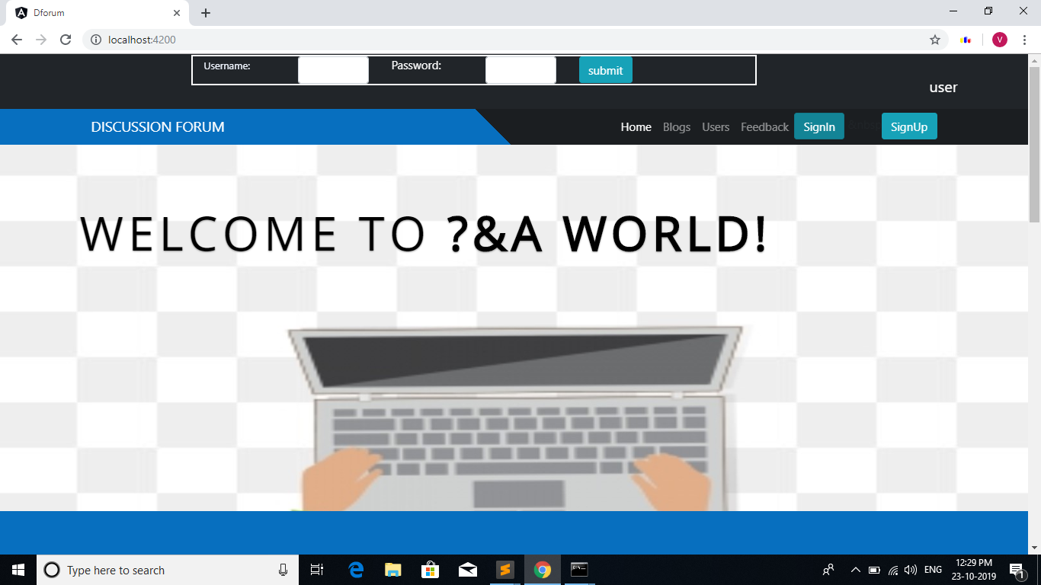

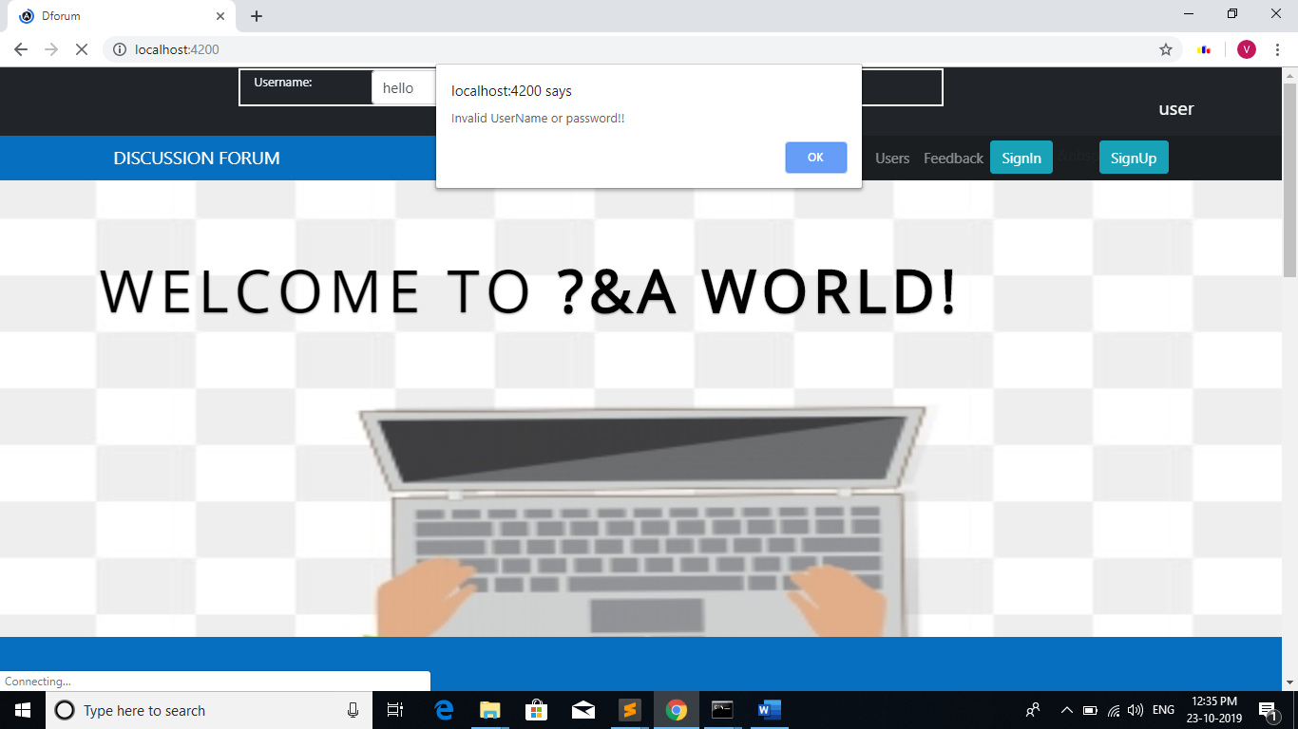

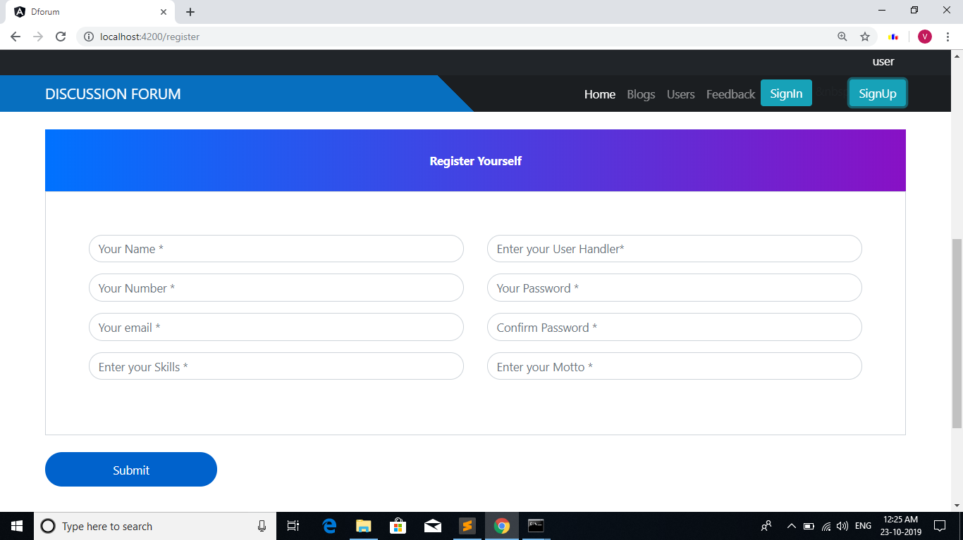

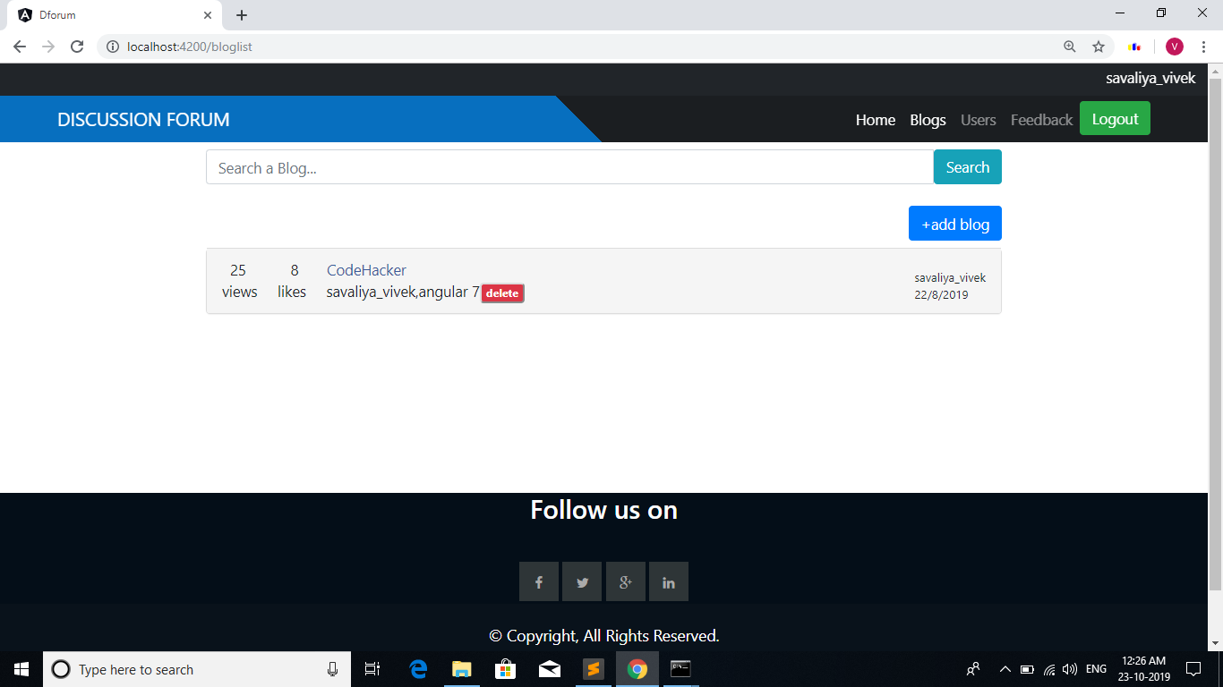

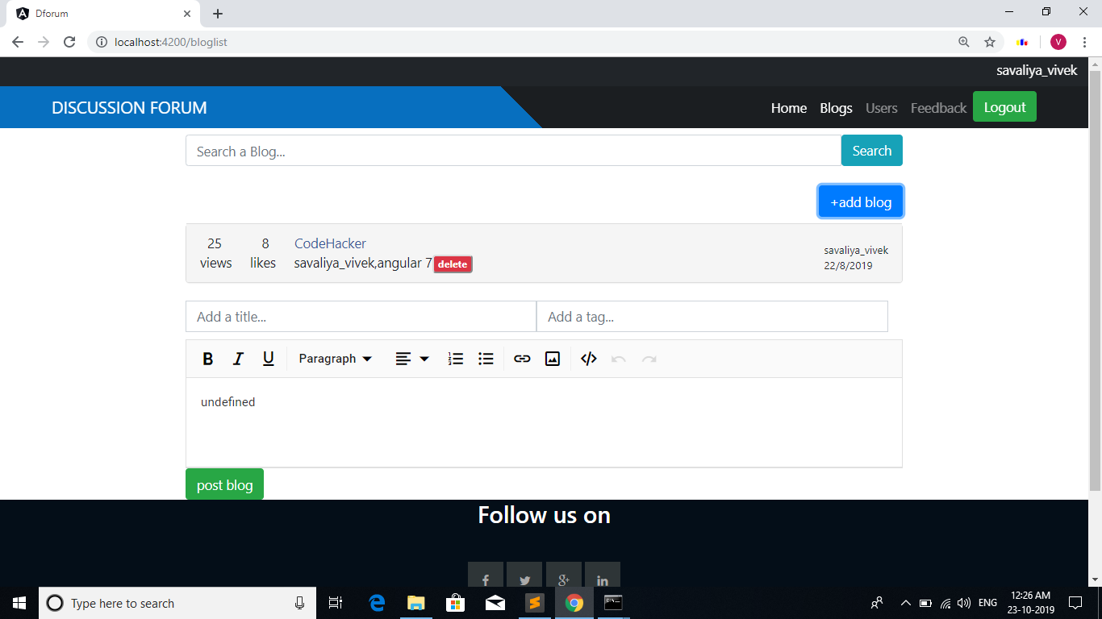

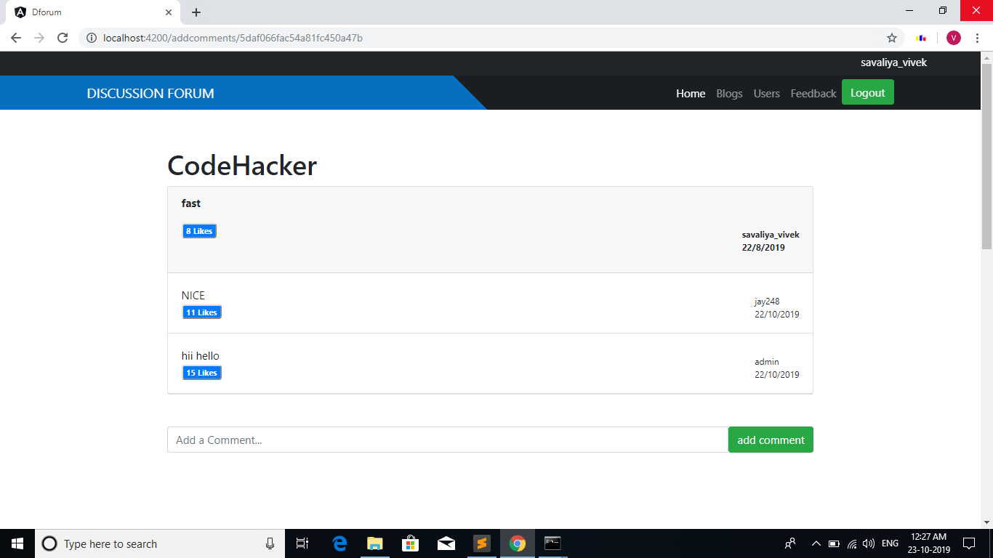

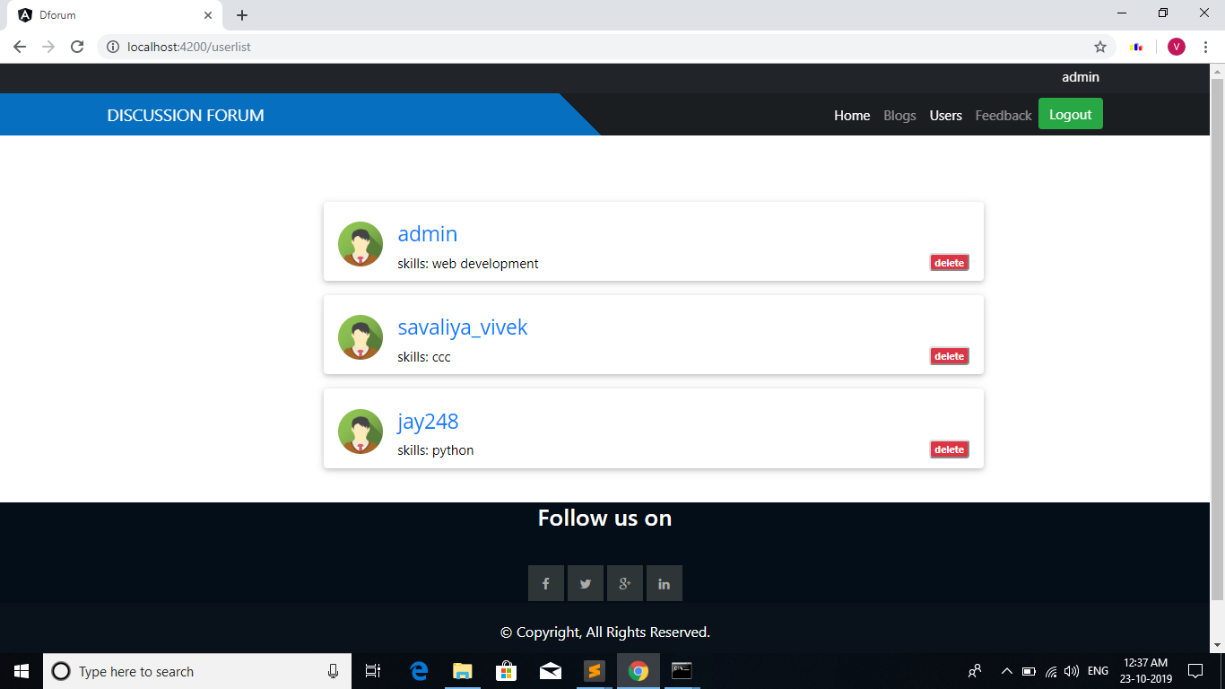

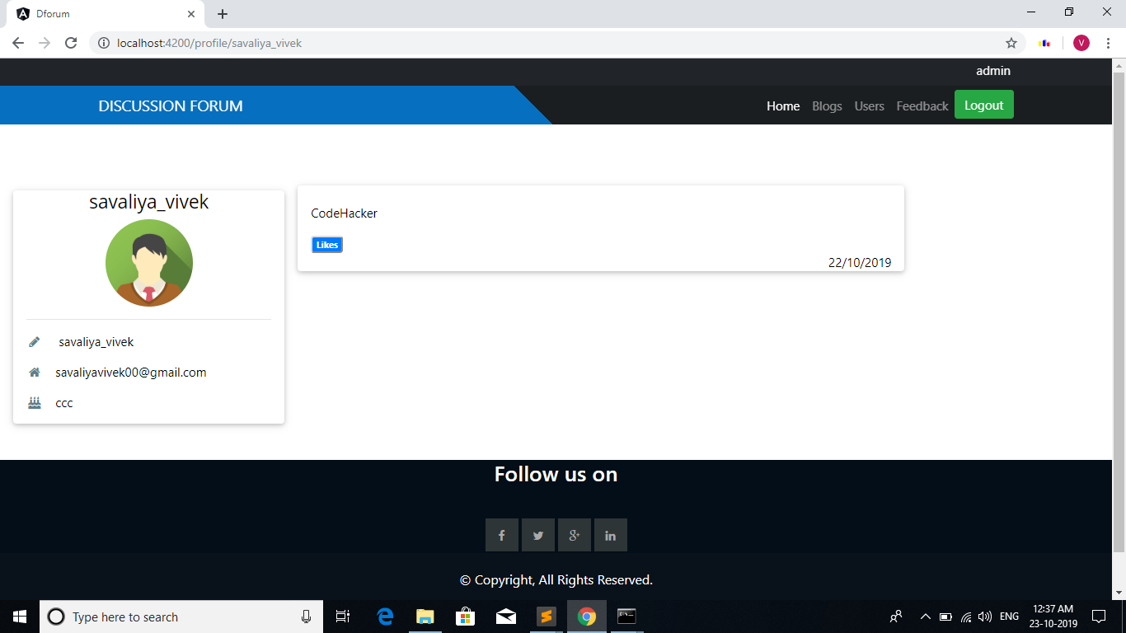

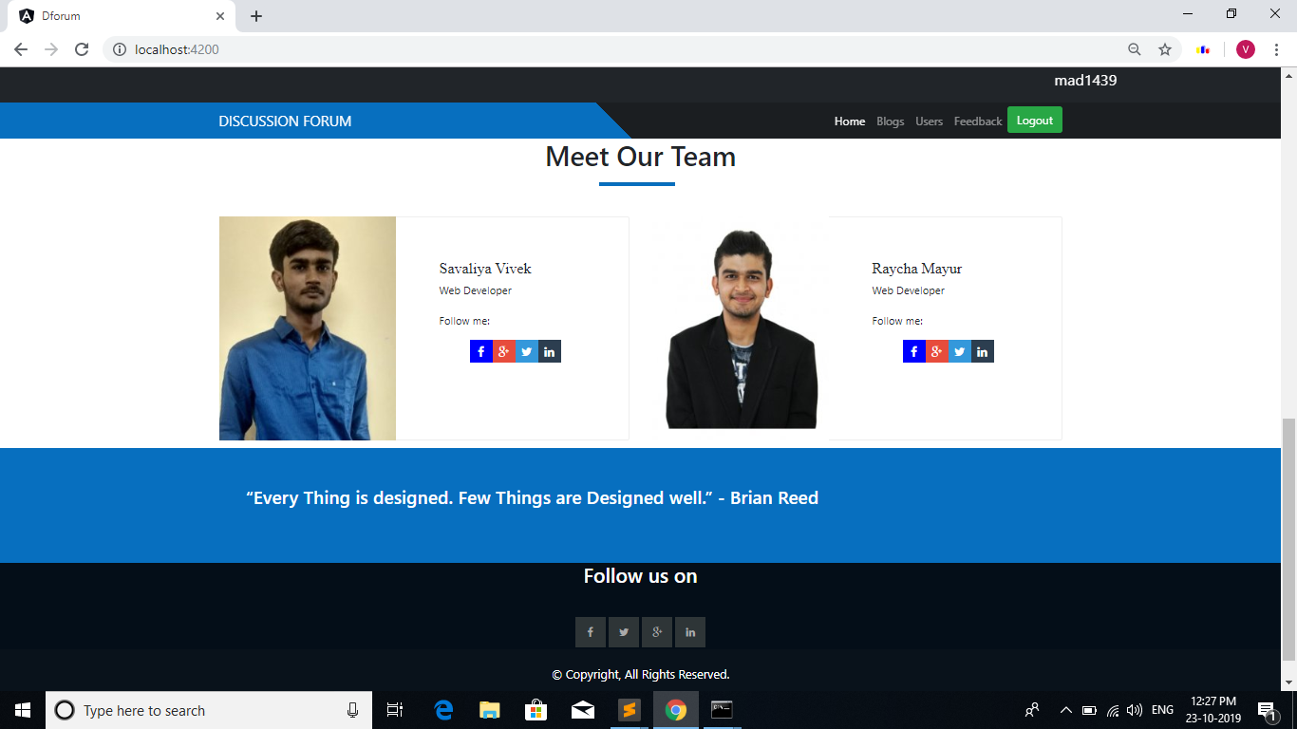

9. Limitations and Future Enhancements

We will include below functionality in future:

* Multilevel searching
* Author can update blog or comment
* User only like blog or comment in one time only, and user also unlike blog or comment
* User can make todo list of favorite blogs or posts
* User make friends/followers
* Many more functionality will be added.

10. Reference / Bibliography

Following links and websites were referred during the development of this project.

<https://www.google.co.in>

<http://www.stackoverflow.com>

<https://github.com/>

<http://www.wikipedia.org>

<http://www.wikipedia.org>

<http://www.getbootstrap.com>

<http://www.w3schools.com>

<http://www.tutorialspoint.com>

<http://www.angular.io>